**Introduction**

The objective of this lab is to learn more about LABVIEW and build a simple circuit to help improve the understanding. LABVIEW is a platform and development environment for creating virtual instruments. Its main applications focus on data acquisition, instrument control, industrial automation of a variety of operating systems. The advantages of this software are that it offers a graphical approach to coding and allows for visualization of every aspect of the application as well as more freedom to customize the user interface.

**Method**

For the virtual heart rate indicator, the steps required include reading the ECG file, calculating the BPM and using a case structure to display different conditions depending on heart rate. For the sample signal, it was taken from the National Instrument database. As for heart rate, multiple blocks were used to find the distance between two R peaks and divided it by 60 to get beat per minute. Depending on the value inputting into a case structure, the condition can either be bradycardia, tachycardia or normal depending on the range it falls in.

**Result**

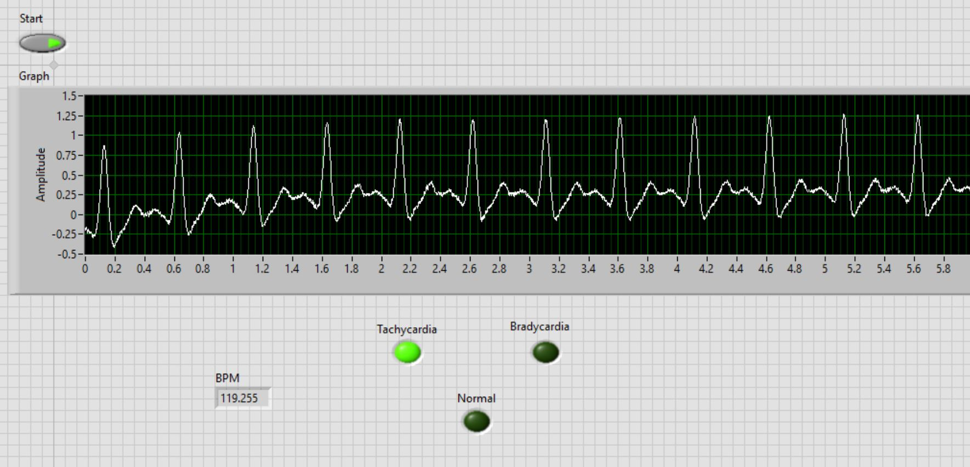

**Discussion**

The range for tachycardia was set to any value above 100, so the tachycardia indicator LED should light up when the BPM is around 119. This is a simple setup that only highlights a small part of what LABVIEW can be used for. Overall, this software is very useful but requires some time to get used to all the functionalities and purposes of each block.

**Code**

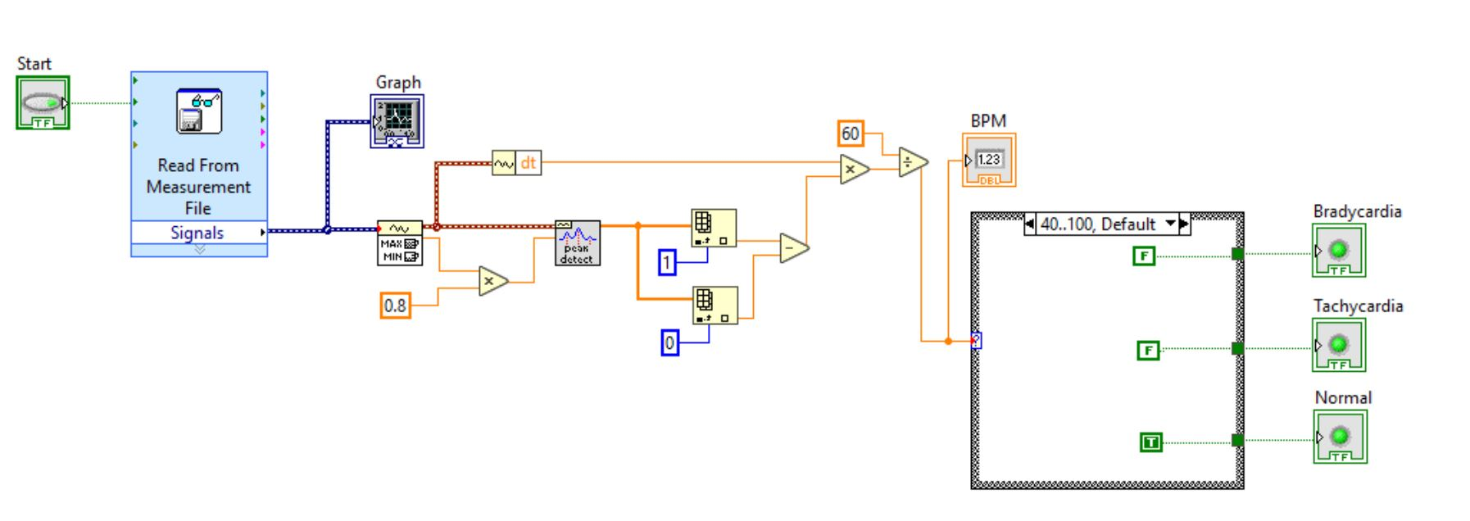

**Source**

Instructables. “Simple ECG Circuit and LabVIEW Heart Rate Program.” *Instructables*,

Instructables,19Dec.2017,https://www.instructables.com/id/Simple-ECG-Circuit-and-LabVIEW-Heart-Rate-Program/.